EU DECLARATION OF CONFORMITY (No 2018-1)
- Product model/product (product, type, batch or serial number):
  - Essentials – Cable reel
  - Model number 217251
  - Batchnumber: PO00026092
- Name and address of the manufacturer or his authorised representative:
Ningbo Hongyi Electronics Technology Co.,Ltd
Guan Haiwei Industrial Zone East Area ,Guan Haiwei Town,
Cixi,Ningbo,Zhejiang 315314,
China
  - www.grouphongyi.com
- This declaration of conformity is issued under the sole responsibility of the manufacturer.
- Object of the declaration (identification of electrical equipment allowing traceability; it may include a colour image of sufficient clarity where necessary for the identification of the electrical equipment):
Schuko type Cabel reel, with 4 ways socket-outlet,with thermal cut-out,with shutters,with cable H05VV-F,2X1.0,40m See pictures:
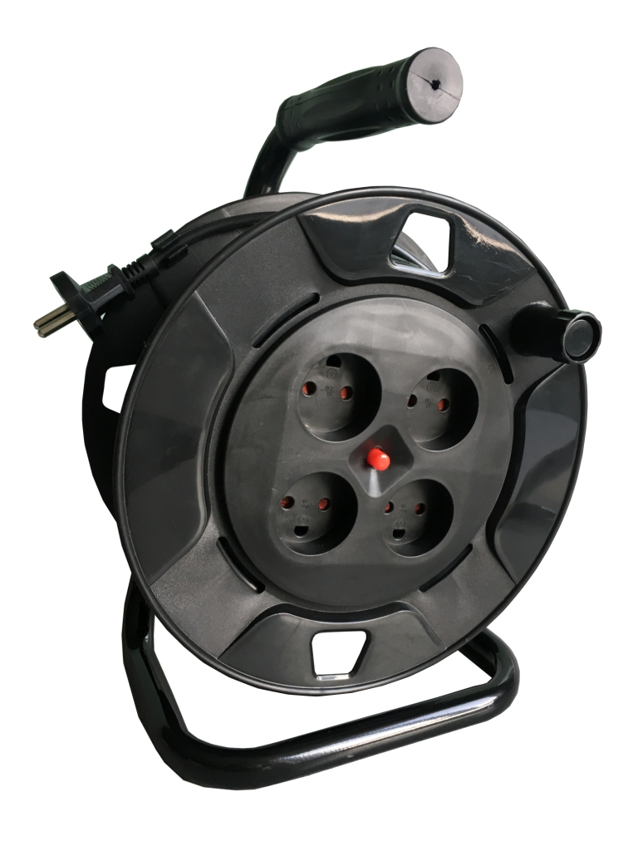
- The object of the declaration described above is in conformity with the relevant Union harmonisation legislation:
  - Low Voltage Directive, LVD 2014/35/EU
  - RoHS Directive, RoHS 2011/65/EU Annex II and its amendment directive (EU)2015/863
- References to the relevant harmonised standards used or references to the other technical specifications in relation to which conformity is declared:
  - EN 61242:1997+A1:2008+A2:2016+A13:2017
  - IEC 60884-1:2002+A1:2006+A2:2013
  - DS 60884-2-D1:2017
- Additional information: None
- Signed for and on behalf of:
Ningbo 2nd Dec-2019
-------------------------------------------------------
Sales manager

